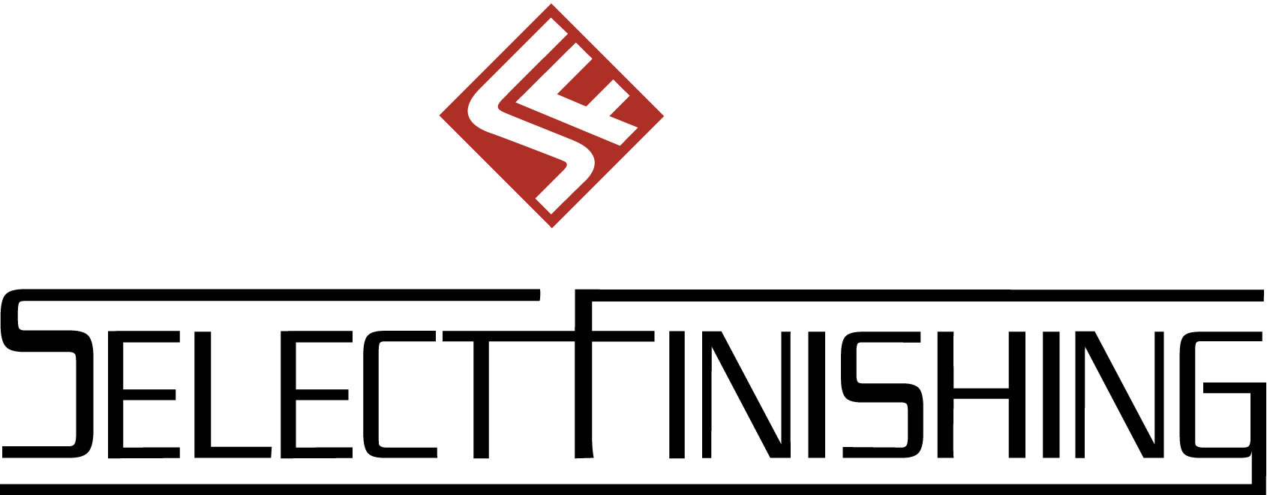

SELECT FINISHING QUALITY ALERT

TO ALL EMPLOYEES

MADE IN CANADA STICKERS MUST BE INSERTED IN EACH PART.

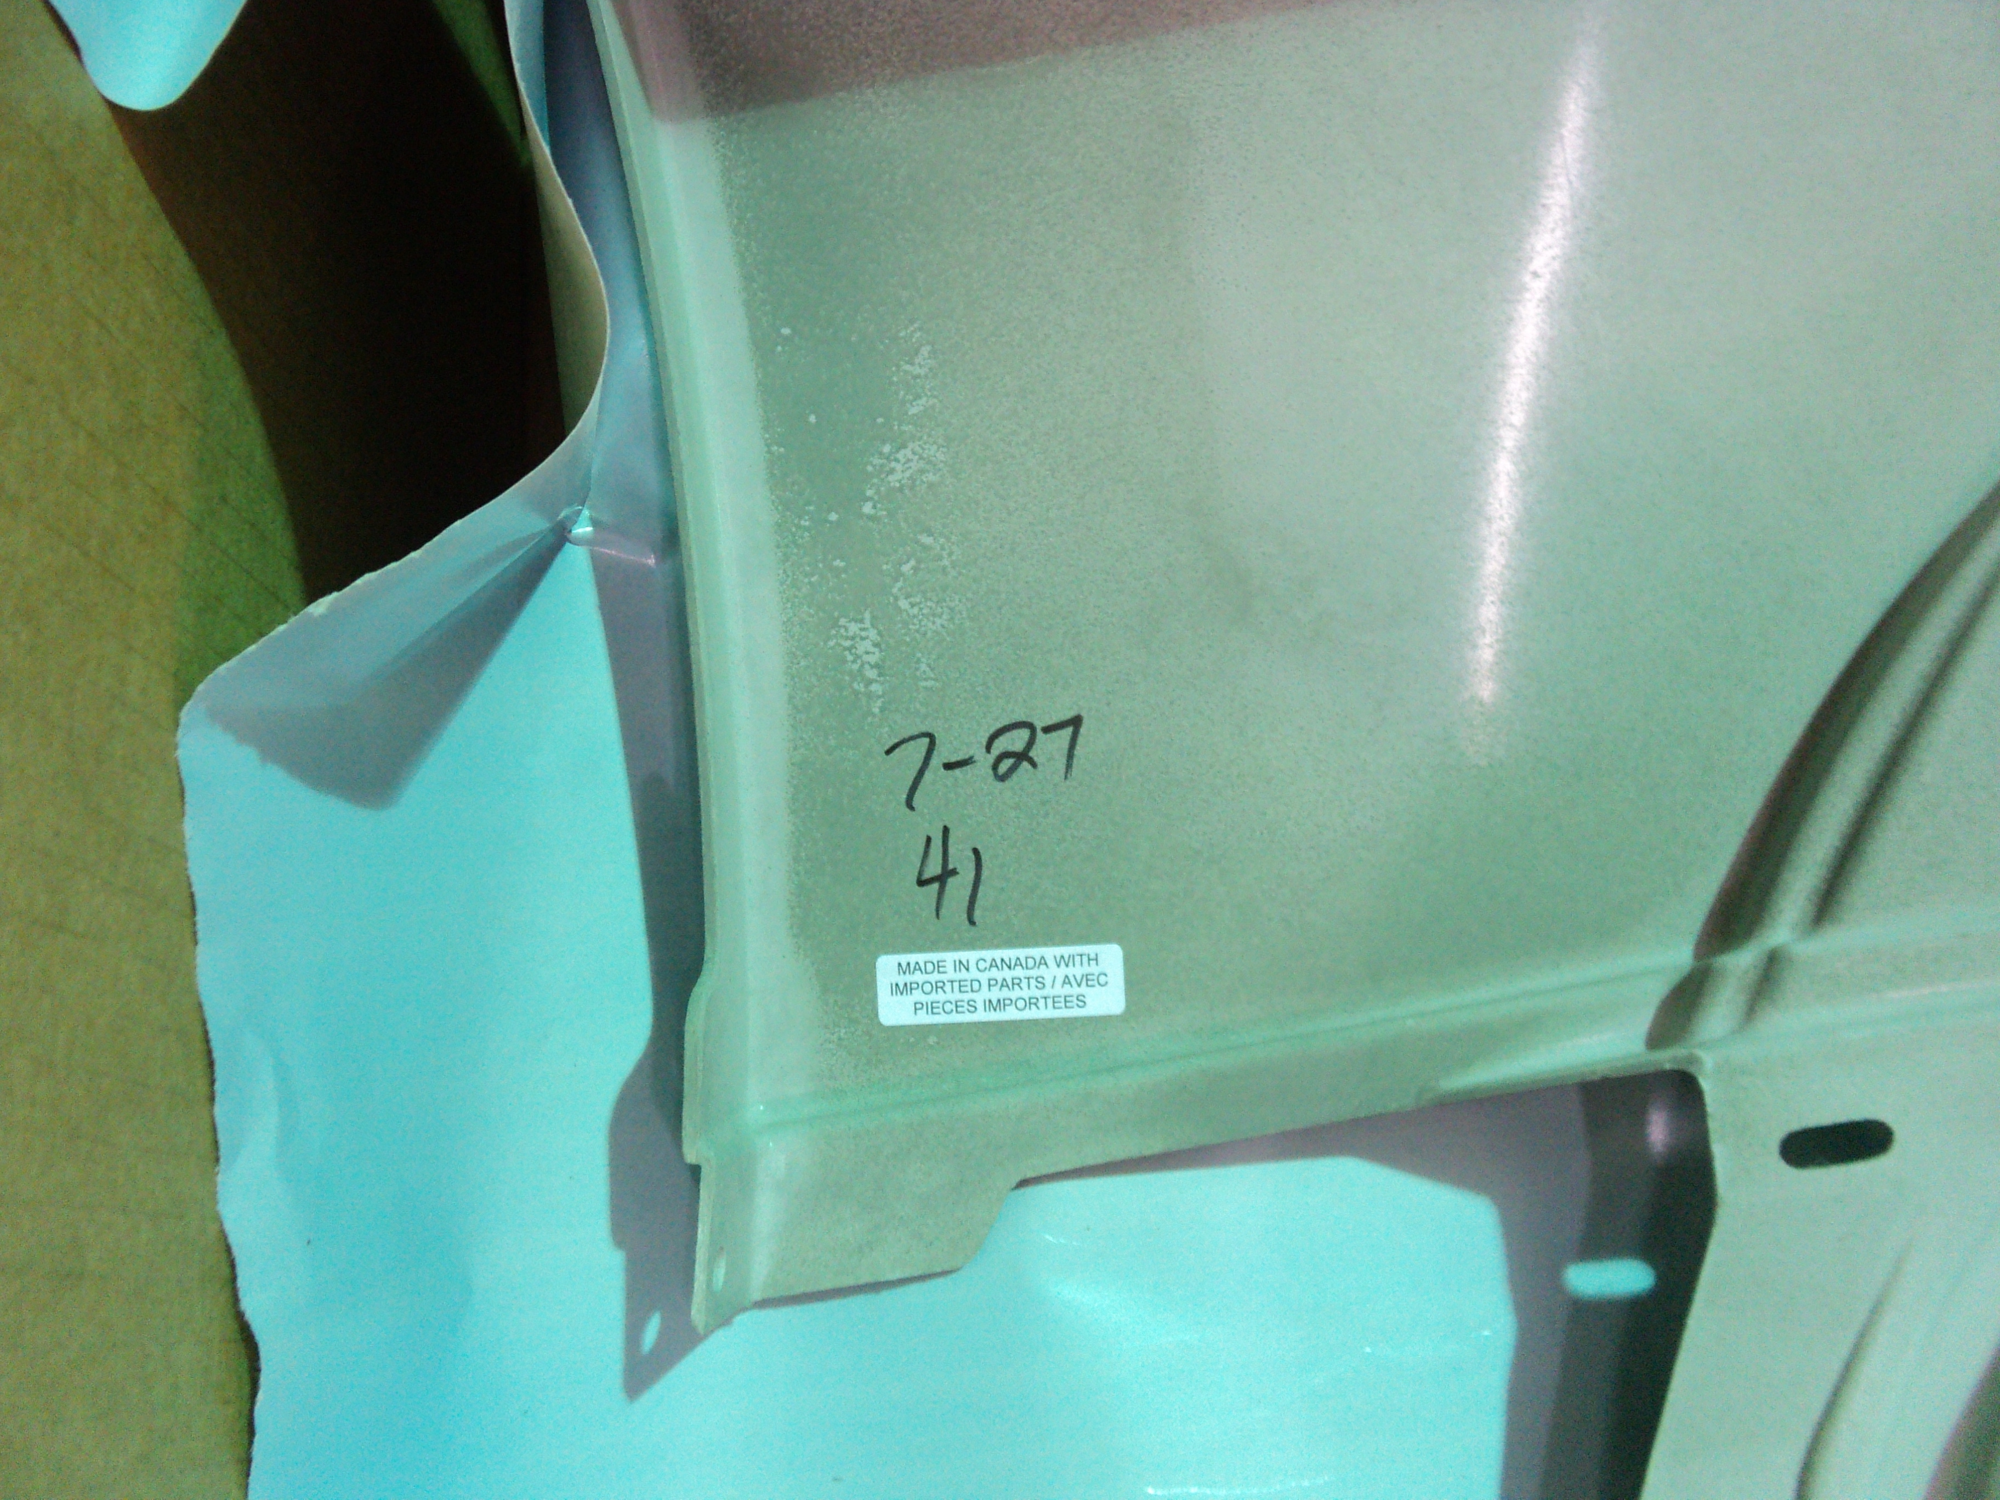

Please Note: All parts MUST have the MADE IN CANADA stickers inserted in each part. If you identify a non-conformance please notify your lead hand/Quality person immediately.

